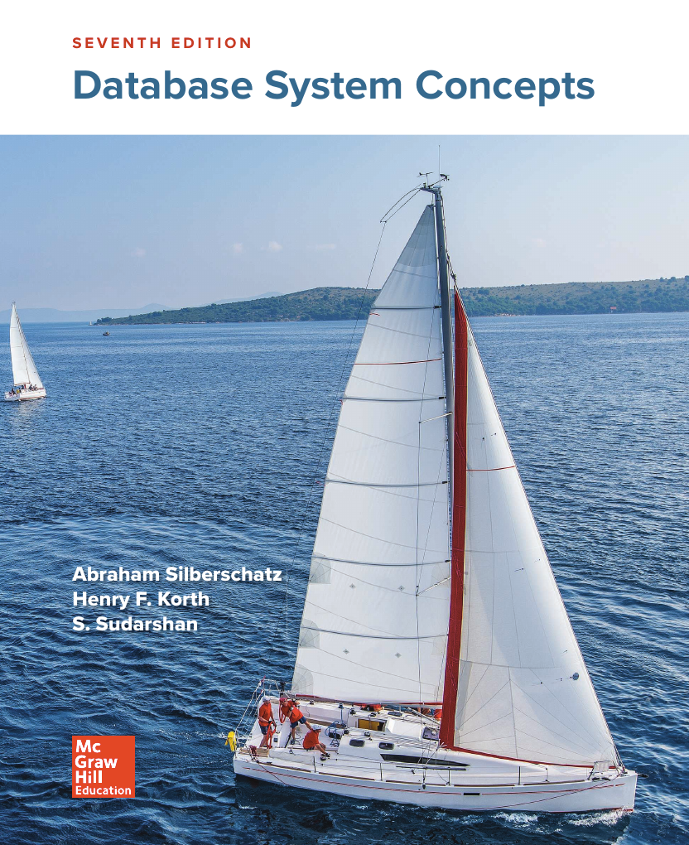
Database System
Concepts ﬁ
Chapter 3





REVISION 1

-------------------------------------------------
Terms (GNU AGPLv3)
This is just a sample!
I have tried to put things like summary, and obviously this is not the solution that I will submit or recommended! I am no way responsible for any illegal use of this file.

If you need direct solutions, please ask DeepSeek, ChatGPT, Google Gemini, Anthropic Claude, Hugging Chat, Le Chat Mistral or any other predictive model.

Chapter 3 | Practice Exercises

Write the following queries in SQL, using the university schema. (We suggest you actually run these queries on a database, using the sample data that we provide on the website of the book, db-book.com. Instructions for setting up a database, and loading sample data, are provided on the above web site.)

a. Find the titles of courses in the Comp. Sci. department that have 3 credits.
select title
from course
where dept_name = 'Comp. Sci.' and credits = 3;

b. Find the IDs of all students who were taught by an instructor named Einstein; make sure there are no duplicates in the result.
select takes_table.ID
from takes takes_table
join teaches teaches_table
on takes_table.course_id = teaches_table.course_id
and takes_table.sec_id = teaches_table.sec_id
and takes_table.semester = teaches_table.semester
and takes_table.year = teaches_table.year
where teaches_table.ID = ( select ID from instructor
where name = "Einstein" ) ;

c. Find the highest salary of any instructor.
desc instructor;
select salary
from instructor
order by salary desc
limit 1;

d. Find all instructors earning the highest salary (there may be more than one with the same salary).
select ID, name
from instructor
where salary = (
select salary
from instructor
order by salary desc
limit 1
);

e. Find the enrollment of each section that was offered in Fall 2017.
select course_id, sec_id, count(*)
from takes
where year = 2017 and
semester = "Fall"
group by course_id, sec_id;

f. Find the maximum enrollment, a ross all se tions, in Fall 2017.
SELECT course_id, sec_id
FROM takes
WHERE semester = 'Fall' AND year = 2017
GROUP BY course_id, sec_id
HAVING COUNT(ID) = (
SELECT MAX(enrollment_count)
FROM (
SELECT COUNT(ID) AS enrollment_count
FROM takes
WHERE semester = 'Fall' AND year = 2017
GROUP BY course_id, sec_id
) AS subquery
);

g. Find the sections that had the maximum enrollment in Fall 2017.
select sec_id, course_id
from takes
where year = 2017
and semester = "Fall"
group by sec_id, course_id
having count(*)
order by count(*) desc
limit 1;

Suppose you are given a relation grade points(grade, points) that provides a conversion from letter grades in the takes relation to numeric scores; for example, an “A” grade could be specified to correspond to 4 points, an “A−” to 3.7 points, a “B+” to 3.3 points, a “B” to 3 points, and so on. The grade points earned by a student for a course oﬀering (section) is defined as the number of credits for the course multiplied by the numeric points for the grade that the student received. Given the preceding relation, and our university schema, write each of the following queries in SQL. You may assume for simplicity that no takes tuple has the null value for grade.

a. Find the total grade points earned by the student with ID '12345', across all courses taken by the student.
select sum(credits * points)
from takes, course, grade_points
where takes.grade = grade_points.grade
and takes.course_id = course.course_id
and ID = '12345';

b. Find the grade point average (GPA) for the above student, that is, the total grade points divided by the total credits for the associated courses.
select
sum(credits * points)/sum(credits) as GPA
from
takes, course, grade_points
where
takes.grade = grade_points.grade
and takes.course_id = course.course_id
and ID= '12345';

c. Find the ID and the grade-point average of each student.
select
ID, sum(credits * points)/sum(credits) as GPA
from
takes, ourse, grade_points
where
takes.grade = grade_points.grade
and takes.course_id = course.course_id
group by ID;

d. Now reconsider your answers to the earlier parts of this exercise under the assumption that some grades might be null. Explain whether your solutions still work and, if not, provide versions that handle nulls properly.
Above solutions won’t work if the answer is null. To fix it, we can use join operations or union operation with null filtering.

Write the following inserts, deletes, or updates in SQL, using the university schema.

a. Increase the salary of each instructor in the Comp. Sci. department by 10%.
update instructor
set salary = salary * 1
where dept_name = "Comp. Sci.";

b. Delete all courses that have never been offered (i.e., do not occur in the section relation).
delete from course
where course_id not in (
select course_id from section
);

c. Insert every student whose tot_cred attribute is greater than 100 as an instructor in the same department, with a salary of $10,000.
insert into instructor
select ID, name, dept_name, 100000
from student
where tot_cred > 100;

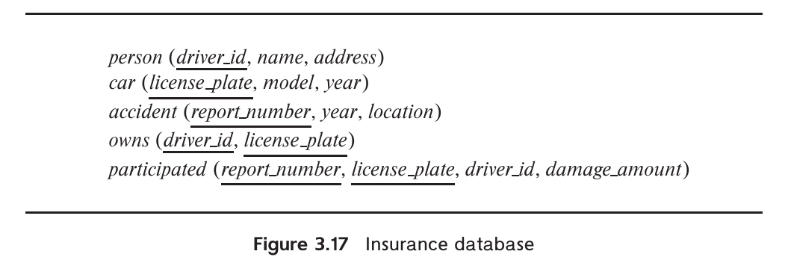
Consider the insurance database of Figure 3.17, where the primary keys are underlined. Construct the following SQL queries for this relational database.

a. Find the total number of people who owned cars that were involved in accidents in 2017.
b. Delete all year-2010 cars belonging to the person whose ID is 12345.

